Note on anamorphic maps
Anamorphic map can be quite useful to show inequalities and contrasts on a map.
Like the countries GDP, Population, number of Internet users (then Africa would be much smaller)
But you could show any information depending on your subject ex sports: number of football players, golf player registered... number of guns owned by private citizens in the country (USA, Brazil, Mexico would be huge, Europe and Asia would be very small except a few countries like Afghanistan...
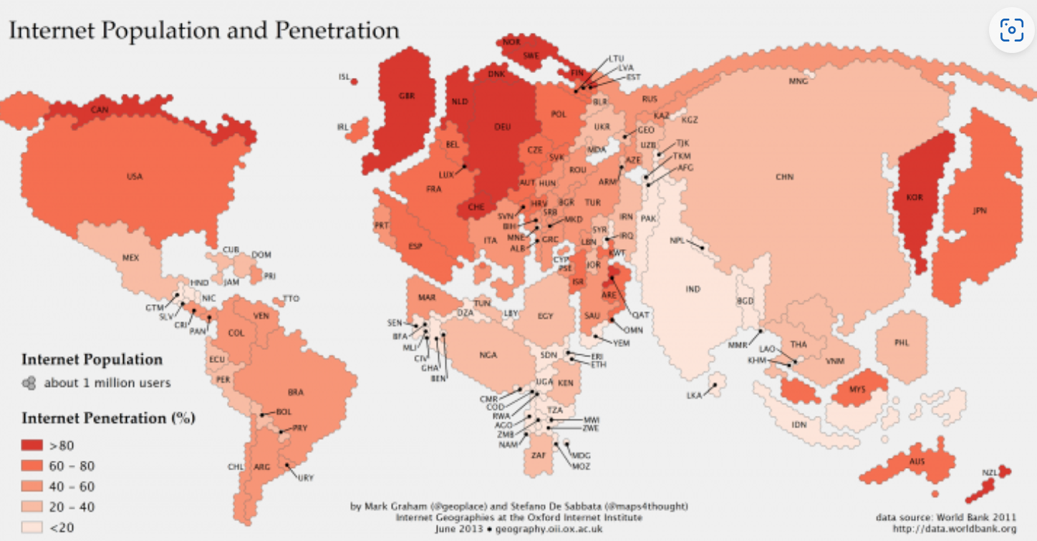
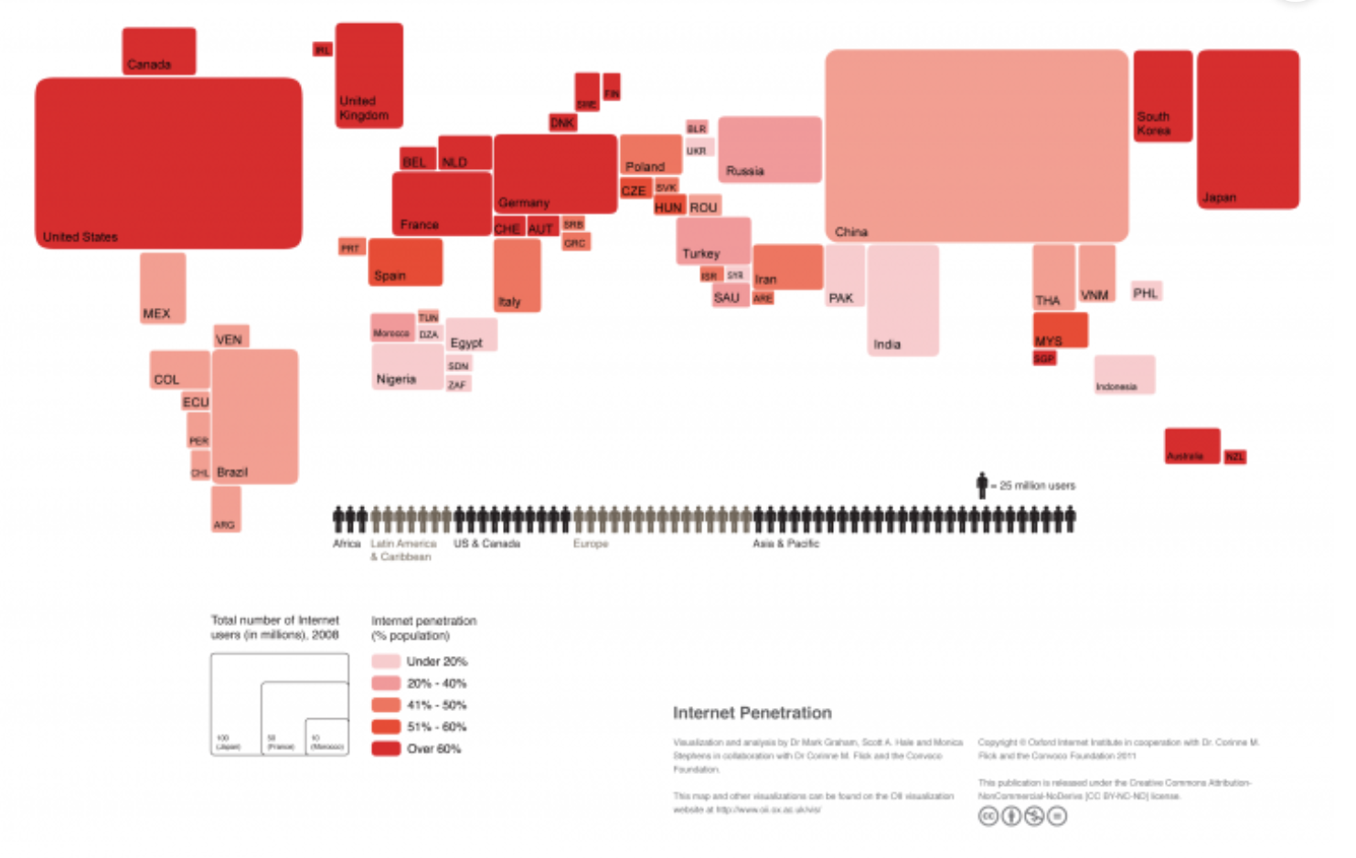
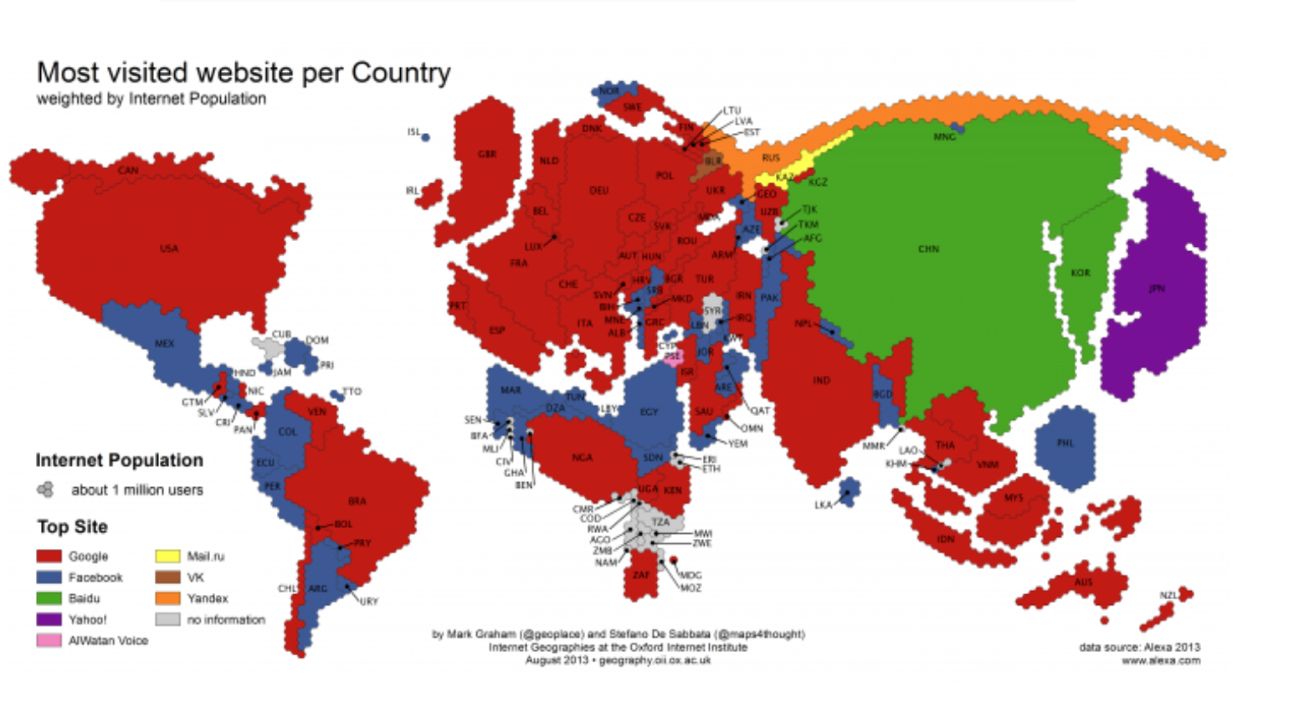

Other examples: CO2 emissions
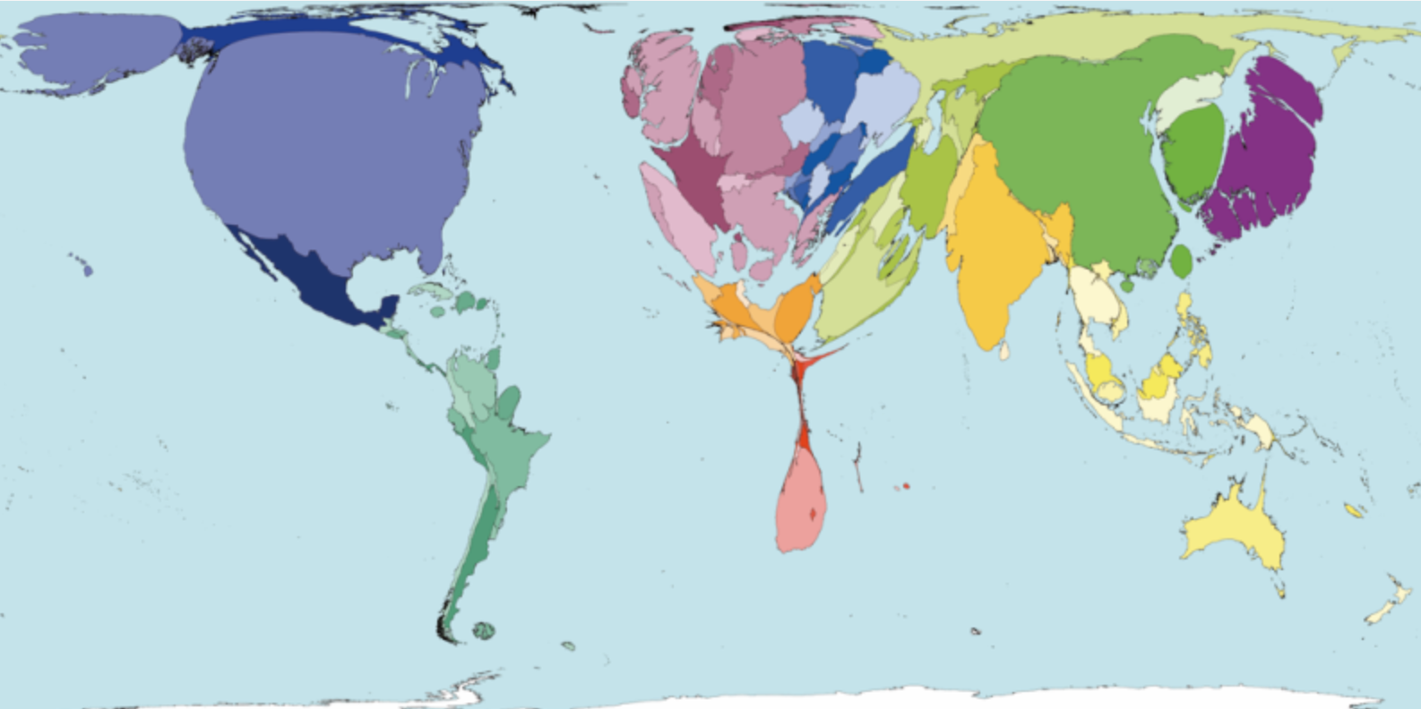

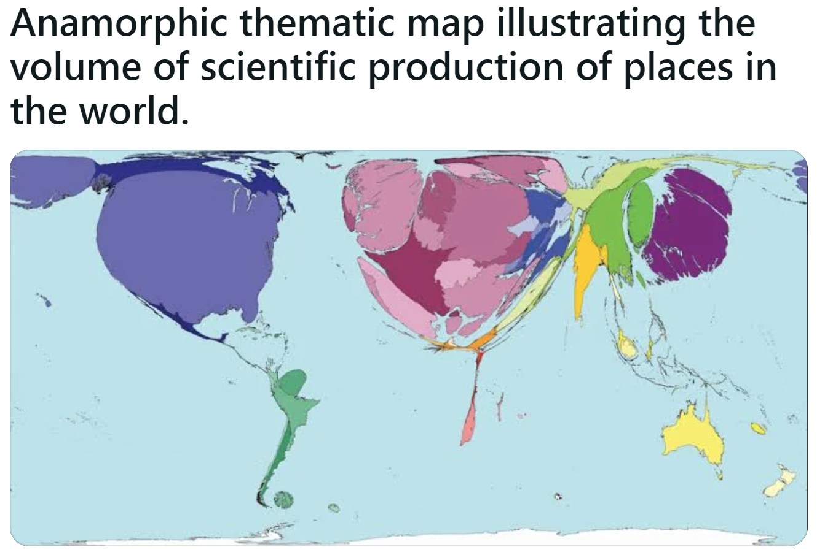
The medals in the PyeongChang Winter Olympics in 2018
This map is more complex as it cross two datas: the number of medals and the number of athletes per medal obtained (= efficiency)
