G1 Geo
学习地理有一件事情非常重要那就是积累case study. 每个topic至少要一个。Case study 指与topic有关的国家或地点的数据信息，但是数据是不要求太多的大概一两个就行。在七分题里，case study是必须的，有case study才有可能在七分题上拿到满分。如果没有case study。不管分析的多好都没有可能在八分题上拿满分（除了某些明确指出不用case study的七分题）。地理的期末考试是4个topic 选了两个进行作答。

Theme 1: population and settlement
  - world population increase
The world population is exploding
Conclusion: 这个完全不会考，因为课本里总共就半页。
  - Over-population and under-population
Over-population: When we are talking about over-population, we are not talking about whether or not it has a large tract of land or anything that has something to do with area that a country has. OVER-POPULATION COUNTRY MEANS THAT THE RESOURCES AND TECHNOLOGY ARE NOT AVAILABLE TO MAINTAIN AN ADEQUATE LIVING STANDDARD FOR TS CITIZENS.
Problems caused by overpopulation:
- Increase rate of crime
- Lack of water and food resources
- Fast spreading speed of diseases
- Bring burden to the healthcare & transportation system
- High level of pollution
- The large need of importation
- Lack of housing
Recommended case study for over-populated country—— Bangladesh
Bangladesh has a total population of 164.7 million (8th most populated country in the world) to its area of 147570 km², it has a population density of 1300 people per km². It is definitely over-populated since it has an average monthly earning of only $300 a month comparing to an average monthly earning of USA of $3500 dollars.
7marks question of over-population

MS (mark scheme)
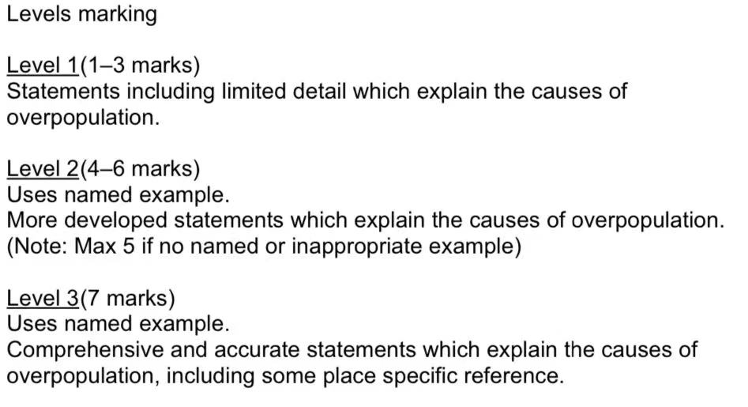

我写的
Bangladesh is the 8th populated country on Earth (about 165 million people). It has a population density of 1300.People living in the country are suffered from these kinds of crowded circumstances and have only an average monthly earning of $300. It is definitely an over-populated country and those phenomena have caused many problems.
Since there are so many people in the country and the country is also overpopulated, the country will lack of essentials resources such as food and water. This problem will lead to importation of goods which cost a large amount of money and bring burden to the local government. Residents that live under this kind of high population density will cause diseases to spread with a higher rate. In the Meantime, large number of people will produce a large amount of pollution as well as bringing burden to the healthcare and transport system. This kind of large population will cause a higher rate of crime which results from such a proportion of people that has been educated because of the financial situation of citizens and fierce competition which will also cause high rate of unemployment.

Under-population: it means that the population a country has cannot use make full use of the resources.
Recommended case study: Australia
Australia is the 7th most underpopulated country which has a population of 24.6 million people and a country size of 7.69 million km². It has a population density of 3 people per km². People are mainly living on the southwestern coastline of Australia where most big city of Australia locate in. The resources of middle Australia have not been fully exploited
Impacts brought by underpopulation:
- Weak national defense
- Lack of people doing essential jobs
- Low rate of unemployment
- Low potential of economic growth
- Low tax revenue
  - Population Change
Abbreviations that you need to know:
- LEDCs-----Less economic developed country
- MEDCs-----More economic developed country
There are mainly two ways of population change:
- Migration
- Natural growth
Migration
Migration can cause the population to decrease or increase. There are mainly two types of migration:
- Emigration: the movement of people moving out of one country to another
- Immigration: the movement of people from another country moving into one country.
Net migration: the difference between number of immigrants and emigrants.
Natural population change
Factors that causing the rapid increase of population:
- Higher yields and more varied diets
- Medicine and medical care which reduces the death rate
- Technology and transport, lead to a wealthier population which increases life expectancy.

