G1 ECON NOTES
  - Section1 The basic economic problem

Chapter 1：Basic Economic PROBLEM

1.1 Finite resources and unlimited want (not essential unit)
  - Vocab:
- Resources: factors used to produce goods and services
- The (basic) economic problem: unlimited want exceeds limited resources
- Scarcity: a situation where there is not enough to satisfy everyone’s needs.
考点：
- Define scarcity (2 point)
- Define economic problem (2 point)
- 答法：背
Conclusion: This unit is the most basic unit among all. Scarcity is related to opportunity cost which is mentioned in chapter 3. Because want is infinite, but resources are limited. People have to make choices on what they want most. EXP: you only have limited money and must decide to survive or buy games!!!!!!!! (评价为废物章节，没什么好记的，economic problem 和scarcity 需要记以外没什么能考的了)

1.2 Economic goods and free goods
Vocab:
- Economic good: a product which requires resources to produce it and therefore has an opportunity cost (best choice forgone when making a decision 这就是机会成本，是前半学期非常重要的知识点，但是很简单，你有一定的资源只能生产一种货物，有两个选择，你选择生产第一种，第二种就是opportunity cost. 这书是会教的chapter3才会有opportunity cost 现在就出来了！！！！！！！)
- Free goods: rarer than economic goods, a product which does not require any resources to produce. (请记住不是免费的，是不用资源生产，免费的可能是free good， 也可能是economic good.)
考点：最多选择题分辨哪个是free good, 哪个是economic good.
Conclusion:1.2 跟1.1 一个性质，有要背的但比较简单，没什么能考的。

Chapter 2: Factors of production

2.1 the importance of factors of production & 2.4 Payments for factors of production
(2.4实在太少了，没必要单独记，没必要实在没必要)
*FOUR FACTORS OF PRODUCTION:
- Land: All natural resources available for production. Reward: rent
- Labor: All human effort includes both mental and physical. Reward: wages
- Capital: often referred to as capital goods and producer goods, goods and services used to produce other goods or services. Reward: interests
- Enterprise: the willingness and ability to bear risks and make key decisions. reward: profit
-Consumer Goods: goods and services that purchased by household for their own satisfaction.
考点：考了但没完全考，记住definition就行，一般与其他知识点混着考，reward 有可能在选择题里考
2.2 Mobility of the factors of production
Vocab:
-Geographical Mobility: capability of moving from one location to another
-Occupational Mobility: capability of changing use
-Immobile is the opposite of immobile

Mobility of Land:
Land is occupationally mobile, geographically immobile.
(land can be used for many purposes but cannot be moved from one place to another)

Mobility of Labor:
Factors of occupational mobility: education/skill level (more educated worker=mobile)
Factors of geographical mobility:
-differences in price/availability of housing in other areas (more expensive=immobile)
-family ties (increased ties = immobile)
-availability of information (unawareness=immobile)
Restriction of movement of workers (more restriction=immobile)

Mobility of Capital:
Geographical and Occupationally mobility VARIES.
Example of
Geographically Mobile Capital: Photocopier (can be shipped to another area)
Geographically Immobile Capital: Coal Mine (cannot move)
Occupationally Mobile Capital: Delivery Van (can be turned into van of other purposes)
Geographically Immobile Capital: Oil Rig (can ONLY be used for drilling oil)

Mobility of Enterprise
DEPENDS ON MOBILITY OF ENTREPRENEURS (Risk-Takers)
-Usually geographically and occupationally mobile when compared to other factors of production

2.3 Quantity and quality of the factors of the production
- LAND
Factors that affect the quantity of land
- The amount of physical land in existence does not change much. There is a certain degree of soil erosion and land reclamation. (不怎么变)
Factors that affect the quality of land
- Fertilizers can be applied to increase the fertility of land.(increase quality的都是类似于停止污染，当然decrease quality就是污染喽)

- LABOR
Factors that affect the quantity of labor
- Size of population (人越多，quantity越多)
- Age structure of the population(与proportion of working age有关)
- Retirement age & school leaving age(决定工作多久，提升school leaving age减少quantity，retirement age越高，potential worker更多.总的来说，就是剥削得越厉害，quantity越多)
- Attitude toward women workers（接受度越高，quantity越多）
The quality of labor: An increase in productivity, including labor quality, is a major cause of an increase in a country’s output
Factors that affect the quality of labor
- Better education
- Better training
- More experience
- Better healthcare（concentrate more, stronger for manual tasks and have fewer days off sick）
- CAPITAL
Factors that affect the quantity of capital
  - Investment and tend to increase with time. (每年capital good 都会损坏或者变得过时.)
Because old capital goods have been worn out daily or become outdated, new capital goods will be replacing the old one. The total value of the output of the capital goods is gross investment. Some of the capital good is used to replace the outdated one. The value of replacement capital goods is called depreciation. Net investment is the value of extra capital goods have been made. (gross investment-depreciation 一般有net这个词就是总的，基本就是正的减去负的)
Factors that affect the quality of capital: technology related things
- ENTERPRISE
Factors that affect the quantity of enterprise (more entrepreneur more enterprise):
- Better education. (文化人多了企业家就多了)
- Lower tax on firms’ profits and a reduction in governments regulations

Factors that affect the quality of enterprise(entrepreneur质量提高)：
- 和提升labor的基本一样
Conclusion：虽然这单元东西比较多但是考的还真不多，看看就行不用记的特别细，记住一些框架就行

CHAPTER 3 OPPORTUNITY COST

3.1 Meaning of Opportunity Cost
-Cost of a decision in terms of the best alternative forgone
考试时比较喜欢考definition，写 the best alternative forgone when making a decision

3.2 Influence of Opportunity cost on decision making

Opportunity cost and consumers:
-consumers choose what to buy
Best alternative they chose not to buy is opportunity cost

Opportunity cost and producers:
-firms choose what to produce (will choose option that generates the maximum profit)

Opportunity cost and workers:
-workers choose what job they want

Opportunity cost and the government:
-government chooses what sector to invest more of in
Conclusion: opportunity cost考的多但是分值普遍不高，记住definition！！！

CHAPTER4 PRODUCTION PROBABILITIES CURVE(PPC)

4.1 A production possibility curve
Production possibility curve is
      - The maximum output of two types of products
      - The combination of those products that can be produced with limited or existing resources and technology
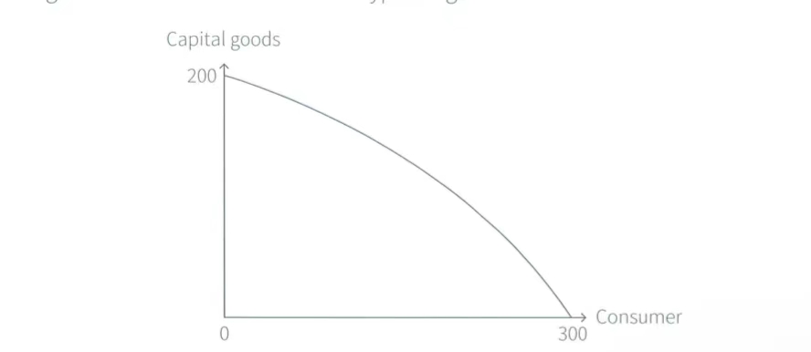

4.2Production points
PPC shows the maximum amount that can be produced
Point X (or any point inside the PPC): output is being produced where there are un employed resources
Point Y (or any point on the PPC): full use of products, full efficiency
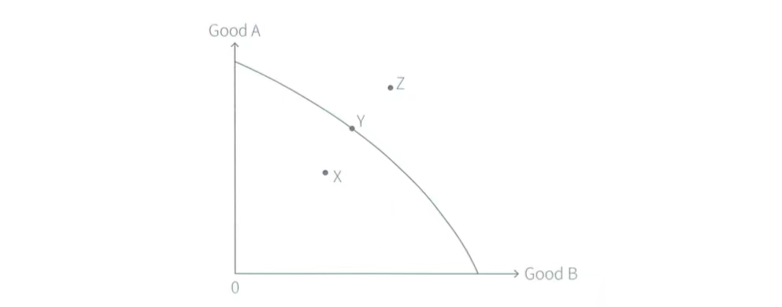
Point Z (or any point outside the PPC): not currently attainable
4.3 Movement along a PPC
A movement along the PPC shows resources have been allocated and indicating a opportunity cost
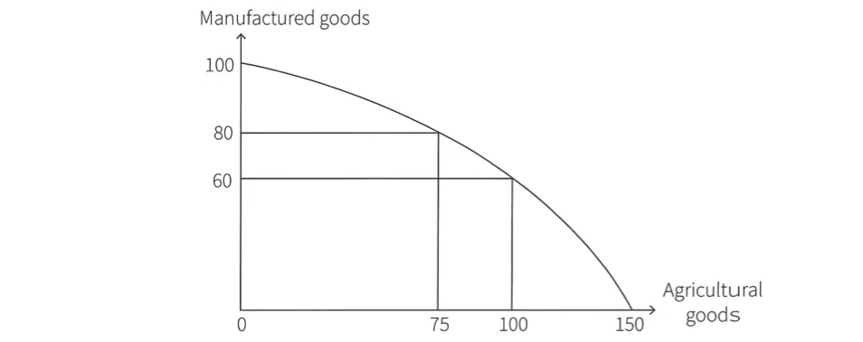
The opportunity cost of increasing agricultural goods from 75 units to 100 units is the lost of 20 units of manufactured goods

4.4 The shape of PPC
The shape of PPC is usually a curve since not every resource is perfectly efficient in making other goods并且一般先挑最不擅长生产A 的去生产B 然后再挑第二不擅长的，所以会有一个increasing opportunity cost. 但是如果都一样擅长生产A，那么PPC就会是一个负斜率的一次函数，如图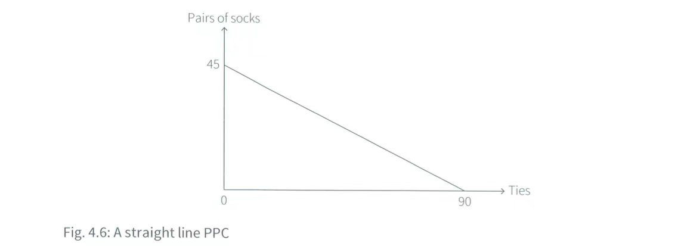
Conclusion：PPC是一个比较重要的章节，并且要知道如何去画PPC，Production points 也要熟知，definition也要去背. 关于PPC的绘画，不能有任何一个PPC与y轴的交点.考试的时候，如果题干理由according to … graph ，这个时候就是表明要画图了，一般6分题才会涉及到画图，图占4分，解释占两分，解释要提及图中的变化以及导致变化的因素，两点即可（多答答错不扣分，建议答三点保险）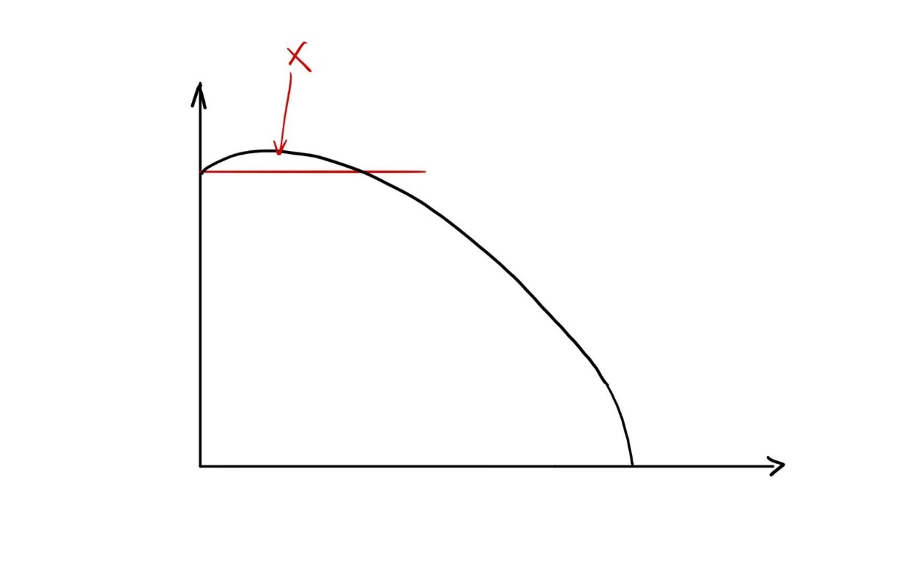

Section 2 The allocation of resources

CHAPTER5 MICROECONOMICS AND MACROECONOMICS

5.1 The difference between microeconomics and macroeconomics
Definition of microeconomics and macroeconomics
Microeconomics is the study of behavior and decisions of households and firms, and the performance of individual markets
Macroeconomics is the study of economics as a whole.

5.2 Decision makers in microeconomics and macroeconomics
The decision makers in microeconomics and macroeconomics are referred to economic agents (those are who undertake economic activities and maek economic decisions). They are mainly households, firms and government.
Households: buyers, savers and workers.
Firms: business concerns that produce goods and services, and employ workers and other factors of production.
Government: produces and provides some of the products and regulate private sector. (firms owned by shareholders and individuals)
Conclusion:考点没有很多，记住microeconomics和macroeconomics的definition就行

Chapter 6 The role of markeys in alloting resources

6.1 The three key allocation decisions
All economies are changing and they have to answer three questions:
- What to produce?
- How to produce it?
- For whom to produce?
These questions arise because the basic economics problem of unlimited want exceed limited resources. All decisions have to be made to determine how resources will be allocated
6.2 Different economic systems
Three main economic systems:
- Planned economic system
- Market economic system
- Mixed economic system (A mixture of planned economic system and Market economic system)
世界现存所有economics system 都是 mixed economics system，只是有些有更多characteristics of planned economics（中国和朝鲜）， 有些有更多market economic system的characteristics（US，UK，France）
Planned economic system：
- An economy that runs planned economic system is called planned, command or collective economy.
- States or governments makes decision about what to produce, how to produce, for whom to produce.
- The states own all or most of the land and capital and employ workers.
- States give directions called directives state-owned enterprises on decisions on what to produce and how to produce
- States decides who get the product made and will offer basic necessities and services for free or with little cost
Market economic system:
- An economy that run market economic system is economic economy or a free enterprise economy.
- An economic system where consumers decide what is produced resources are allocated automatically through the price mechanism (the way decisions are made by households and firms ‘interaction of allocating resources), and land and capital are owned privately.
- In a market economy, government intervention is minimal. Firms get to decide how to produce products that consumers want to buy. Some firms are capital-intensive (the use of high proportion of capital relative to labor), some are labor-intensive (the use of high proportion of labor relative to capital.
6.4 the role of price mechanism (6.3 是 market economy)
In market economy, resources are automatically allocated by the change of price. Price change is determined by the market force of demand and supply.
Price mechanism provides incentive for producers to react to the changes in the market condition. The use of resources is always changing all the time in response to the

