G1 Computer Science Notes

Semester One: Programming and Logic (Unit 7-8)
_______________________________________________________________________________________________
Part ONE
Introduction of the Program development life cycle and its four stages
_______________________________________________________________________________________________
Program development life cycle (PDLC)
1. Meaning
-A structured plan of how to create a system/software
That is organized into stages (In IGCSE we say there are four stages)

2. Four stages of PDLC
These parts will be explained later!
_______________________________________________________________________________________________
Analysis
1. Meaning
Identify the problem and requirement

2. Abstraction
Keeps the key elements required for the solution to the problem and discards any unnecessary details and information that is not required.
(e.g. when you are asked to draw a world map, you won’t mind the shape of SCIE)

3. Decomposition
Taking a system and splitting it into smaller sub-systems, which can in turn be split into smaller sub-systems.
(e.g. eat food = put it into your mouth + chewing + swallowing)

_______________________________________________________________________________________________
Design
1. Meaning
Show the programmer all the tasks that need to be completed to meet the program specification, how each task is to be performed and how the tasks work together

_______________________________________________________________________________________________
Coding
1. Meaning
Write program code and test it iteratively

_______________________________________________________________________________________________
Testing
1. Meaning
test program code with the use of test data

2. What do we test
Check if the program
-fully works
-does not crash
-meets all requirements
_______________________________________________________________________________________________
Part Two
Design Stage
_______________________________________________________________________________________________
Structure Diagram
1. Meaning
-A structure diagram shows how each system and sub-system is broken down from top to bottom.
-It is developed by decomposing a program to its sub-programs.
(e.g.
)
2.2 Component parts of a computer system
-Inputs: the data used by the system that needs to be entered.
-Processes: the tasks that need to be performed using the input data and any other previously stored data (e.g. subtract the input data by 2)
-Outputs: information that needs to be displayed or printed for the users of the system.
-Storage (you don’t necessarily need to put this in a structure diagram): data that needs to be stored in filed on an appropriate medium for use in the future.
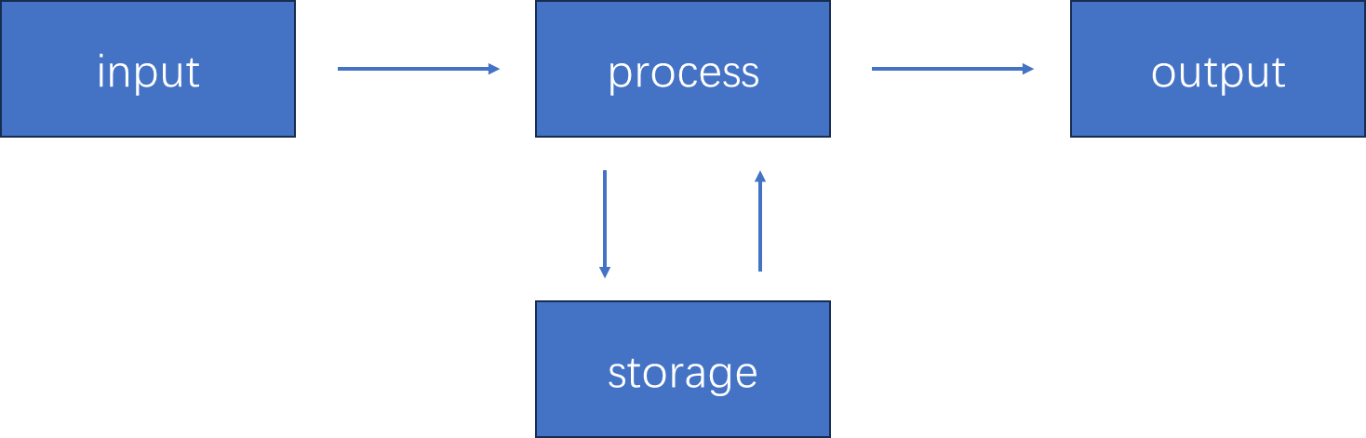

2.3 Example

_______________________________________________________________________________________________
Flowchart
1. Meaning
A flowchart is a diagrammatic representation of an algorithm.

2. Standard Symbols
1) ( Start/Stop )
-A flowchart starts with a Start box, and ends with an End box.
-There is 1 arrow pointing to/starting from such boxes.
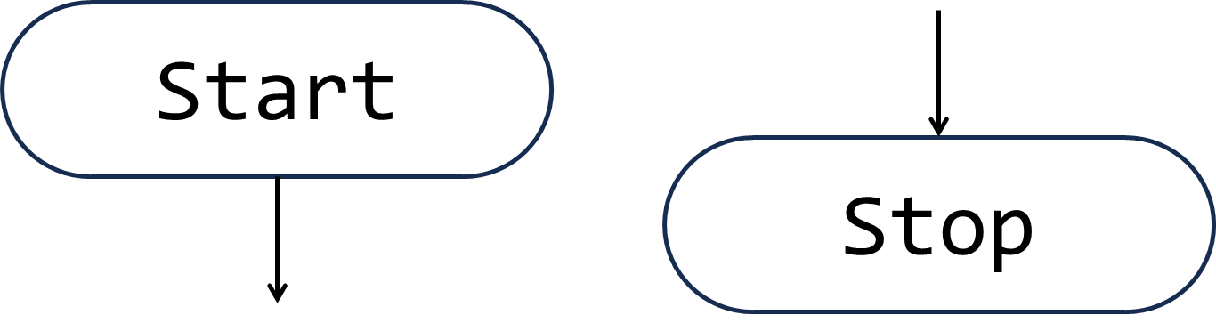

2) / Input/Output /
-An Input box allows input a value for a variable.
-An Output box allows output a text.
-There are 2 arrows, one pointing to and one starting from such boxes.
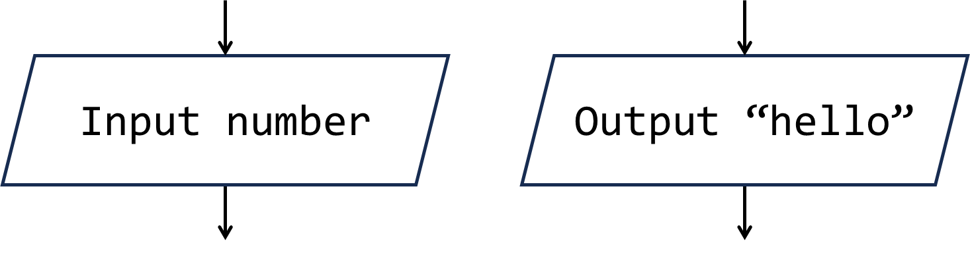\

3) | Process |
-An Action that is being performed, usually mathematical calculation.
-There are 2 arrows, one pointing to and one starting from such boxes.
-In flowchart and pseudocode, when we resign a value to a variable, we use instead of = (ignore the textbook if it uses =)
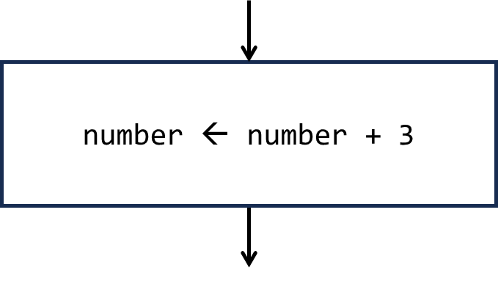

4) < Decision >
-A Yes-or-No question with two outcomes.
-There are 3 arrows, one pointing to and two starting from such boxes.
-The question is usually a comparison using:
= | equal to
> | greater than
< | less than
>= | greater than/equal to
<= | less than/equal to
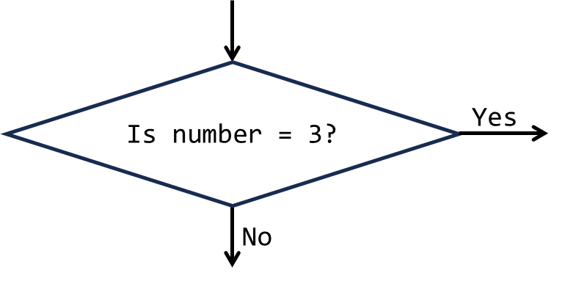
_______________________________________________________________________________________________
Pseudocode
1. Meaning
Code-like statements that are used to design an algorithm but do not follow and specific language
(e.g.
Hungry TRUE
IF Hungry = TRUE
THEN
OUTPUT “I am Hungry”
ELSE
OUTPUT “I am not Hungry”
ENDIF
)

2. Notice
-Although it is not a specific language and does not follow a defined, mandatory syntax, using recommended style in the syllabus enables you to communicate with the examiner more efficiently.
-In real exams you can write pseudocode in your own style as long as the examiner understands (don’t do that).
-While in SCIE exams you will probably get your mark deducted if you don’t follow the recommended style.
-In a word, you have to remember and use the recommended style anyhow OMO.

We will discuss quite a lot about pseudocode, so…
We will discuss pseudocode in the next several parts!
_______________________________________________________________________________________________
Part Three
Pseudocode: Variables & Data types
_______________________________________________________________________________________________
Meaning
Variable and constant are memory locations with identifiers that stores a value, you can understand them by:
Imagine a box with a label on it, which you can put things in it
-the box is the variable
-the label is the identifier of the variable
-the things you put in it is the value you resign to the variable
-you can change the value in the variable
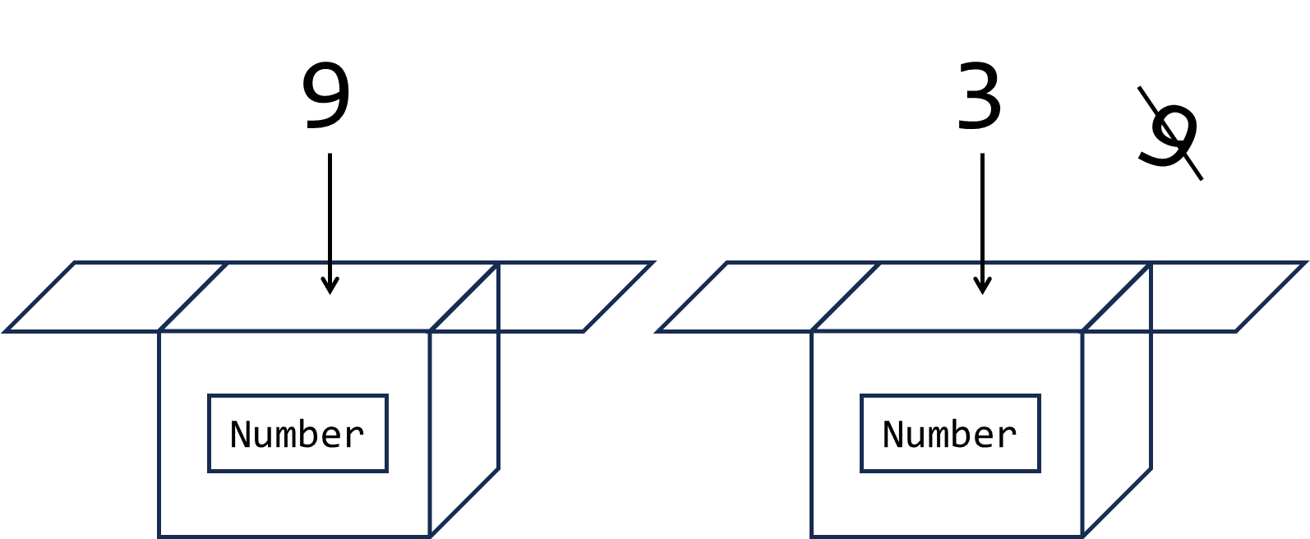

-constant is almost the same as variable, but you cannot change the thing you put in it
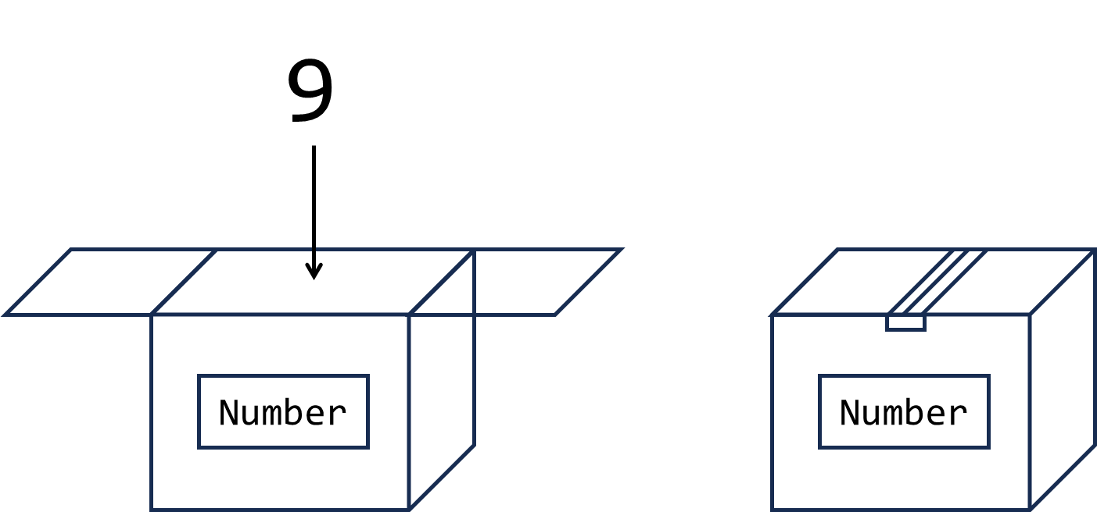

-After you resign the value to a variable/constant, you can find the value by using the identifier
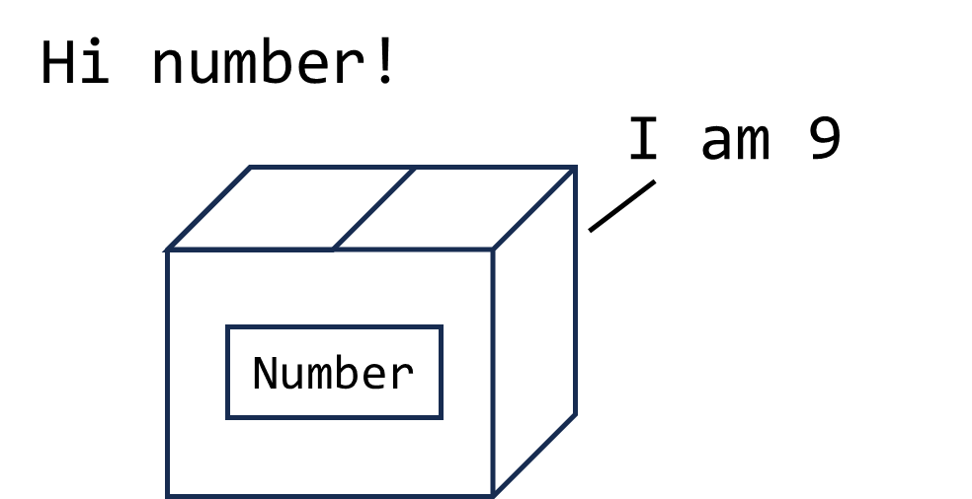
N
N
(e.g.
Status “hungry”
OUTPUT Status

OUTPUT|
Hungry
)
_______________________________________________________________________________________________
Declare
-In pseudocode, you need to declare a variable/constant before using them. (it’s like building up a box)
-Which means, you need to clarify what type of data does the variable stores.
-Notice: For convenience, the examples in this note may not include declaration, but it is better to declare the variable each time before using it in pseudocode
1. Variable
DECLARE <identifier> : <data type>

2. Constant
CONSTANT <identifier> <value>

_______________________________________________________________________________________________
Assign value
-In pseudocode, you can assign a value to a variable by using

<identifier> <data type>
_______________________________________________________________________________________________
Data types
type | meaning | examples
INTEGER | A whole number | 33 2023
REAL | A number containing a fractional part | 3.23 7.0
CHAR | -A single character  -It uses single ‘’ | ‘a’ ‘3’
STRING | -A sequence of zero or more characters  -It uses double “” | “Hello, world” “”
BOOLEAN |  | TRUE / FALSE

_______________________________________________________________________________________________
Part Four
Pseudocode: Operators & Common Operations
_______________________________________________________________________________________________
Arithmetic operators
operator | meaning
+ | addition
- | subtraction
* | multiplication
/ | division
^ | raise to the power of
DIV(a, b) | divide a by b and ignore the decimal part
MOD(a, b) | gives the remainder of a divided by b
(e.g.
DIV(3, 2) gives 1
MOD(5, 3) gives 2
)
_______________________________________________________________________________________________
Logical operators (comparison)
operator | meaning
= | equal to
< | smaller than
<= | smaller than or equal to
> | larger than
>= | larger than or equal to
<> | not equal to
(e.g.
3 <= 3 is TRUE
3 <> 3 is FALSE
)
_______________________________________________________________________________________________
Boolean operators
operator | meaning
a AND b | If a and b are both TRUE, it will be TRUE, else it will be FALSE
a OR b | If a and b are both FALSE, it will be FALSE, else it will be TRUE
NOT a | If a is FALSE, it will be TRUE  If a is TRUE, it will be FALSE
(e.g.
3 = 5 AND 4 = 4 gives FALSE
TRUE OR FALSE gives TRUE
)
_______________________________________________________________________________________________
INPUT
-In pseudocode, you can ask the user to input the value of a variable by using

INPUT <identifier>

_______________________________________________________________________________________________
OUTPUT
-In pseudocode, you can output a message by using

OUTPUT <message>

-You can join several messages together by using ,

OUTPUT <message_1>, <message_2> etc.
_______________________________________________________________________________________________
Part Five
Pseudocode: Sequence, Selection & Iteration
_______________________________________________________________________________________________
Sequence 序列
-Sequence is basically run the series of statements from up to down and each of them are run once
(e.g.
OUTPUT “Hello”
Message “Hello again!”
OUTPUT Message

OUTPUT|
Hello
Hello again!
)

_______________________________________________________________________________________________
Selection 条件
-Selection determines which code is run according to the scenery
-notice: if the (Line N) has a bracket, it is not necessarily needed (e.g. ELSE in IF statement)
1. IF statements
1 IF <condition>
2 THEN
3 <statements>
4 ELSE
5 <statements>
6 ENDIF

Line 1 IF statements start with IF and the condition that you want to check
Line 2-3 If the condition is satisfied, the statement(s) (can be several lines) will be run
(Line 4-5) If the condition is not satisfied, the statement(s) (can be several lines) will be run
Line 6 The IF statements end with an ENDIF

(e.g.
Number 3
IF Number = 3
THEN
OUTPUT “It is 3”
ELSE
OUTPUT “It is not 3”
ENDIF

OUTPUT|
It is 3
)

2. CASE statements
1 CASE OF <identifier>
2 <value 1>: <statement>
3 <value 2>: <statement>
4 OTHERWISE <statement>
5 ENDCASE

Line 1 CASE statements start with CASE OF and the identifier of the variable that you want to check
Line 2/3 If the variable equals to the value, the statement will be run (There can be multiple values)
(Line 4) IF the variable is not equal to all the values, the statement will be run
Line 5 The CASE statements end with an ENDCASE

(e.g.
Color “red”
CASE OF Color
“red”: OUTPUT “Apple”
“blue”: OUTPUT “Blueberry”
“green”: OUTPUT “Grass”
OTHERWISE OUTPUT “I don’t know”
ENDCASE

OUTPUT|
Apple
)

Notice: the statements that will be run is determined by:
The condition for IF statements
The value of a variable for CASE statements
You cannot use a condition in CASE statements or a value of a variable in IF statements
_______________________________________________________________________________________________
Iteration/Loop 循环
-Iteration or loop is where statements are run a number of times, or run when/until a condition is True
1. FOR…TO…NEXT loop (count-controlled loop)
- The action/process are repeated a finite number of times
1 FOR <identifier> <value1> TO <value2> (STEP <value3>)
2 <statements>
3 NEXT <identifier>

Line 1 The FOR loop runs several times, starts with identifier given the value value1, each time it is added value3, and the loop ends when the identifier is equal to or larger than value2. (STEP <value3> does not have to be included and the STEP is 1 by default)
Line 2 The statements that are run
Line 3 The FOR loop ends with NEXT <identifier>

(e.g.
FOR Number 1 TO 3
OUTPUT Number
NEXT Number

OUTPUT|
1
2
3
)

2. REPEAT…UNTIL loop (post-condition loop)
-The action/process are repeated until a given condition becomes TRUE (Thus the statements inside will at least be run once as it checks the condition each time after running them)
1 REPEAT
2 <statements>
3 UNTIL <condition>

Line 1 The REPEAT loop starts with REPEAT
Line 2 The statements that are run
Line 3 The REPEAT loop ends when the condition is TRUE

(e.g.
Number 0
REPEAT
Number Number + 1
OUTPUT Number
UNTIL Number = 3

OUTPUT|
1
2
3
)

2. WHILE…DO…ENDWHILE loop (pre-condition loop)
-The action/process are repeated while a given condition is TRUE (Thus the statements inside can be not run at all if the condition is not satisfied)
1 WHILE <condition> DO
2 <statements>
3 ENDWHILE

Line 1 The WHILE loop starts with WHILE <condition> DO, and ends when the condition is FALSE
Line 2 The statements that are run
Line 3 The WHILE loop ends with ENDWHILE

(e.g.
Number 0
WHILE Number <> 3
Number Number + 1
OUTPUT Number
ENDWHILE

OUTPUT|
1
2
3
)
_______________________________________________________________________________________________
Part Six
Pseudocode: Techniques
_______________________________________________________________________________________________
*The examples below are not the only way to solve these problems, you can try to find another way to do so
Finding the Total/Count/Average
- Totalling
If we want to find the total of numbers that the user enters in iteration, we can use a variable that increases by the value that the user enters each time, for example:
//remember to declare the variable
Total 0
REPEAT
INPUT Number
//increase the value of the variable by the value that user enters each time
Total Total + Number
UNTIL Number = -1
OUTPUT Total

- Counting
If we want to find the number of values that the user enters in iteration, we can use a variable that increases by 1 that the user enters each time, for example:
//remember to declare the variable
Count 0
REPEAT
INPUT Number
//increase the value of the variable by 1 each time
Count Count + 1
UNTIL Number = -1
OUTPUT Count

- Average
If you combine the totaling and counting, you can find the average by Total/Count, for example:
Count 0
REPEAT
INPUT Number
Total Total + 1
Count Count + Number
UNTIL Number = -1
Average = Total / Count
OUTPUT Average

Finding the Minimum/Maximum
- Minimum
If we want to find the minimum number that the user enters, there are two ways of doing so

1.Assign a really big number to the variable first, and compare the variable with the user input each time
Minimum 9999
REPEAT
INPUT Number
//compare the value of the user input and the Minimum variable
//if the number is smaller than the Minimum variable, assign this value to the variable
IF Number < Minimum
THEN
Minimum Number
UNTIL Number = -1
OUTPUT Minimum

2. You can also ask the user to enter a number first and assign it to the Minimum variable!
INPUT Number
Minimum Number
REPEAT
INPUT Number
IF Number < Minimum
THEN
Minimum Number
UNTIL Number = -1
OUTPUT Minimum

- Maximum
Its basically the same as finding the minimum, but the opposite

1.Assign a really small number to the variable first, and compare the variable with the user input each time
Maximum -9999
REPEAT
INPUT Number
//compare the value of the user input and the Maximum variable
//if the number is larger than the Minimum variable, assign this value to the variable
IF Number > Maximum
THEN
Maximum Number
UNTIL Number = -1
OUTPUT Maximum

2. You can also ask the user to enter a number first and assign it to the Maximum variable!
INPUT Number
Maximum Number
REPEAT
INPUT Number
IF Number > Maximum
THEN
Maximum Number
UNTIL Number = -1
OUTPUT Maximum
_______________________________________________________________________________________________
Part Seven
Validation & Verification
_______________________________________________________________________________________________
-When there is a data that has been copied or input, we should check if the data was reasonable and accurate.
-Thus, we use Validation to check if the data input is reasonable and verification if the data is copied accurately

In pseudocode, allow user to input again if the input is invalid by using iteration (loop)
*The examples below are not the only way to solve these problems, you can try to find another way to do so
Validation
The checking of data to make sure it is reasonable and within set bounds
1. Range check
-To check if the data is within one or two bounds. (If it is larger/smaller than a number etc.).

(e.g.
INPUT Number
WHILE Number < 3 DO
OUTPUT “Please enter a number larger or equal to 3.”
INPUT Number
)
2. Length check
-To check if the number of characters is within a set limit.

-In pseudocode, we use
LENGTH(<STRING>)
To give the number of characters in a string

(e.g.
LENGTH(“Hello friend!”) gives 13
(Notice that blank and symbols count as a character)
)

3. Type check
-To check if the data is the correct data type.

(e.g.
Check if the number is an INTERGER by using
DIV(Number, 1)
(DIV(Number,1) = Number if Number is INTEGER)
)
4. Presence check
-To check if the data has been entered

(e.g.
For STRING, if it is empty, it will be equal to
“”
)

5. Format check
-To check if the data meets a specific order,

(e.g.
A date should be “yyyy-mm-dd”,
If it is “121-hello-today”, it is considered as invalid
)
6. Check digit
-a digit that is compared to see if the data entered is correct

(e.g.
Assume that the first digit of a phone number should always be 1,
If the user enters “212 5670 8912”, it is not reasonable,
As the first digit is 2
)

Validation
Checking that data is entered accurately, that it is the same as the original.
1. Visual check
-Comparing the data entered with the original by looking at them (uhh…okay)
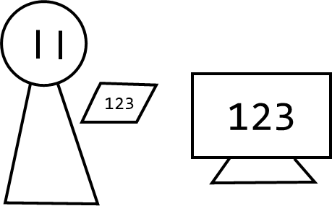
2. Double entry check
-Enter the data twice (usually by different people) and compare them
-kind of like websites which ask you to enter your password twice!
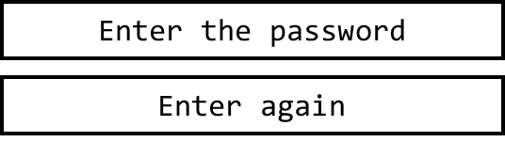
_______________________________________________________________________________________________
Part Eight
Trace Table
_______________________________________________________________________________________________

